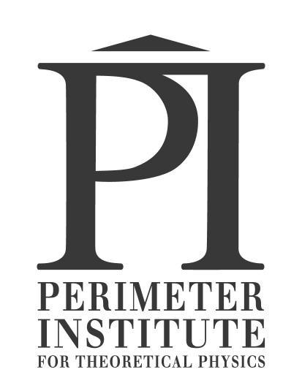

Optics Workshop
Apr. 27, 2012 Session A, 10:45am-noon Time Room
Jason Harlow
University of Toronto, Senior Lecturer in Physics

Light is all around us, and it is our main way of perceiving our surroundings. These are some concept-based discussion activities and some hands-on activities, meant to be done in teams of 3 or 4. In this workshop we study how light travels through a room to our eye, image reversal in mirrors, refraction of light through a prism, total internal reflection, and the effects of convex and concave lenses.

Latest revision: Mar. 20, 2012

Concepts of this Module
- The Law of Reflection
- Diffuse versus Specular reflection
- Focus of a concave spherical mirror
- Image Formation in Plane Mirrors.
- Refraction and Total Internal Reflection.

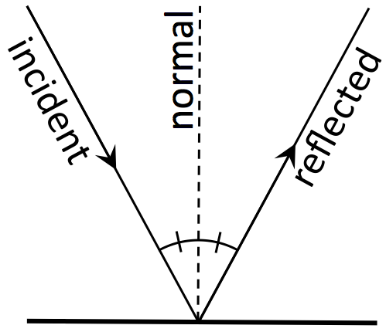

Activity 1 Background:

Specular Reflection means reflection from a polished, perfectly flat surface that obeys the Law of Reflection: angle of incidence = angle of reflection. Note that angles are measured from the normal. The normal is the line which is perpendicular to the surface, pointing out from where the incident ray hits the surface.
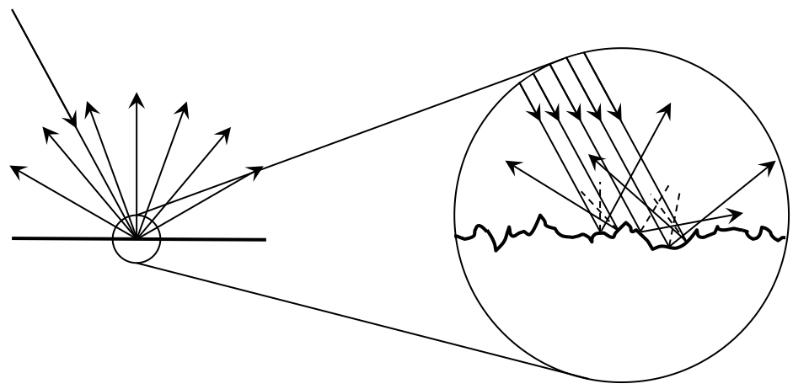

Diffuse Reflection is reflection of a surface that is rough on a microscopic scale: angle of reflection can be anything!

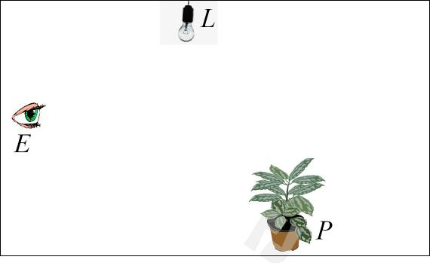
Activity 1: How do we see?

- Imagine a room that contains a light source, L, a plant P, and an observer with an eye, E, as shown.
The observer, E, sees the plant, P. However, if the light, L, is off, the observer sees nothing.
Sketch some rays that will allow the observer to see the plant. If light is reflected, indicate if the reflection is diffuse or specular.

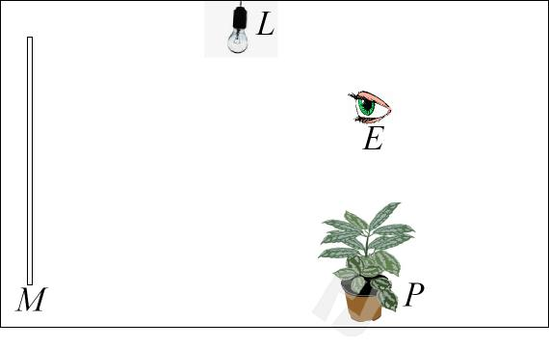
- Imagine a room that contains a light source, L, a plant P, an observer with an eye, E, and a mirror, M, as shown.
The observer, E, sees an image of the plant, P in the mirror, M. However, if the light, L, is off, the observer sees nothing.
Sketch some rays that will allow the observer to see the plant in the mirror. If light is reflected, indicate if the reflection is diffuse or specular.

[INSTRUCTOR HINTS for Activity 1 – note these are not meant for the student guide]
This simple little Activity introduces the idea which many people do not find intuitively obvious: that light rays must travel from a source, reflect off an object, and end up in your eye in order for you to “see” the object. The eye is always the last one to receive the rays.
- The light goes L P E, with a diffuse reflection at P. The law of reflection need not be obeyed at P, because the plant is a diffuse reflector.
- The light goes L P M E, with a diffuse reflection at P but a specular reflection at M. The students should be careful to draw the rays obeying the law of reflection (angle of incidence equals angle of reflection) when reflecting off the mirror.

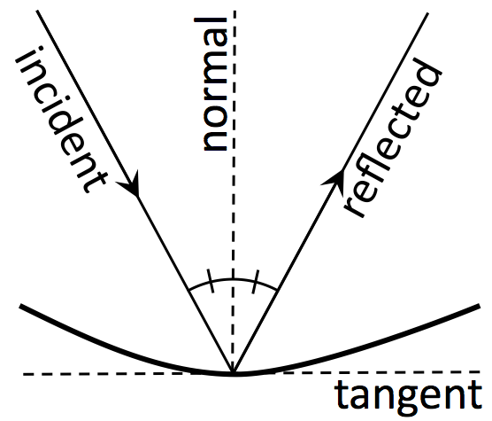
Activity 2 Background:

Recall the Law of Reflection: angle of incidence = angle of reflection. The law of reflection applies to curved surfaces as well. The normal is the line which is perpendicular to the tangent plane at the point where the incident ray hits the surface.

Concave mirrors can focus parallel rays of light. This is a result of the law of reflection.

Activity 2: Where is the Focal Point of a Concave Spherical Mirror?

- Imagine a few parallel rays of light shine onto the concave surface of a spherical mirror. This is shown on the next page. Please label the centre of curvature of the mirror as C on this diagram. Note that the ray which passes through C reflects along its own normal (angle of incidence = 0°), and so passes again through C.

Equipment Needed for Activity 2 part B | Qty
Small semi-circular protractor, 10 cm in diameter | 1
Ruler | 1

- Four other parallel rays are shown which do not pass through C. The normal is drawn as a dashed line for each incident ray. Note that, for a sphere, the normal to the surface always passes through C. Use the protractor to measure the angle of incidence, and use the law of reflection to draw the correct reflected ray for each of the four incident rays.
- Most of the rays will pass through a certain small region called the “focal point”. Please label this point F on your diagram. Note that rays farther from the central ray do not quite pass through F; this is called spherical aberration.

[INSTRUCTOR HINTS for Activity 2 – note these are not meant for the student guide]
Many textbooks claim that the focal point of a spherical mirror is half-way between the centre of curvature and the surface of the mirror. This activity shows why. Textbooks usually fail to mention that this is only true for rays which are very close to the central ray. This activity shows what happens when rays are further from the central ray; they do not pass through F but form a blurry focus.

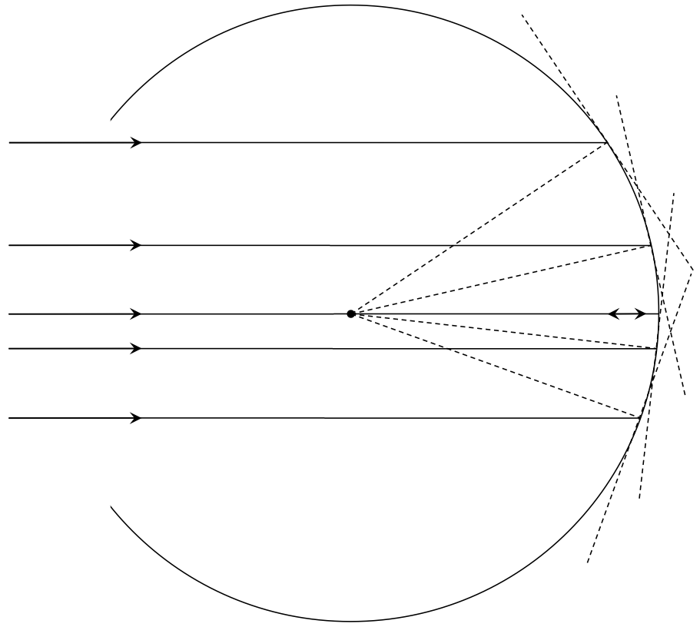

Activity 3

- “Why do mirrors reverse left and right and not up and down?” Alice and Bob stand in front of a large mirror in a dance studio, looking at themselves. Alice wonders if their images are reversed “left and right” or “up and down”. She looks at Bob’s image in the mirror and memorizes what he looks like. Then she asks Bob to turn and face her, so she can compare the image to what Bob looks like in real life. Bob takes a couple of steps forward, turns around and faces Alice. Alice notes that, compared his the mirror image, Bob appears reversed left and right! Alice concludes: Mirrors reverse left and right, not up and down. Is this true? Can you see any flaws in Alice’s reasoning?

Equipment Needed for Activity 3 part B | Qty
Mirror which can be balanced vertically, perhaps 30 cm by 30 cm | 1
Small sign on thin paper with the bold word “Charles Dodgson” printed on it | 1

- You are supplied with a small sign on which is printed “Charles Dodgson”, which was Lewis Carroll’s real name. Hold the sign up to the supplied mirror with the writing facing the mirror: you will see the text in a mirror image. If the ink has seeped through the paper a bit, you may also be able to see the writing directly by looking at the back of the sign. Is there any difference between the appearance of the writing as seen in the mirror and the writing as seen from behind? Now curve the sign so the edges are closest to you and centre, about where the D is, is furthest away from you. Look at the sign in the mirror. In the mirror image are the edges curving towards you or away from you? In Part B, you may have concluded that mirrors reverse left and right. Do you want to change that conclusion? What do mirrors really reverse?

[INSTRUCTOR HINTS for Activity 3 – note these are not meant for the student guide]
- The idea here is: Mirrors reverse front to back. They do NOT reverse left to right or up to down. Bob needs to turn in order to face Alice, and he in effect has two choices of how to do this: he can stand on his head or he can rotate about a vertical axis. Since humans are fairly symmetric about our vertical axes it is easiest to turn this way, so we do it every time. That’s why we seem to think mirror reverse left and right: it is Bob that reverses that way, not the mirror.
- Again this should reinforce the idea that mirrors reverse front to back, not left to right.

Activity 4

Equipment Needed for Activity 4 | Qty
Basic Optics Light Source, Pasco OS-8470  $201 from www.pascocanada.com | 1
Glass Rhombus [Ginsberg Scientific 7-909-81 Lens And Prism Set - Acrylic - 7 Pieces for $40 from www.amazon.com ] | 1
Small semi-circular protractor, 10 cm in diameter | 1
Ruler | 1

This activity uses the “Ray Box” feature of the PASCO Basic Optics Light Source. Place the light source flat on the table or on a white piece of paper so it is sitting on its four little legs and plug it in. There is a wheel to select one, three or five parallel rays projected onto the table. If you place it on a piece of paper the rays will be easier to see and you can trace them with a pen or pencil.

Note: The lights in the room need to be dimmed and the blinds lowered for these activities to be effective!
You also should have a transparent glass trapezoidal prism, a small protractor and a ruler.
Trapezoidal prism: 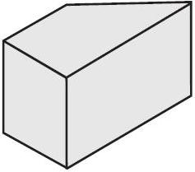

- Select the 1-ray and shine it on a piece of paper. Place the trapezoidal prism in the beam. You should see that part of the ray is refracted through the trapezoidal prism, but there also is a reflected ray. Adjust the angle of incidence. How does the brightness of the reflected ray vary with the angle of incidence? [Note, the angle of incidence is defined as the angle between the incident ray and the normal from the surface which emerges at the point where the ray touches the surface.]

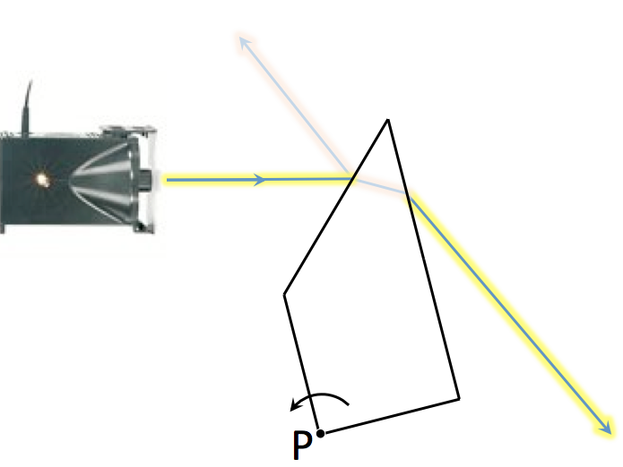
- Choose an angle of incidence, and carefully sketch and label the incident ray, the reflecting surface of the trapezoidal prism, and the reflected ray. Use the ruler and protractor to sketch and label the normal to the surface at the point where the ray reflects. Measure the angle of incidence and angle of reflection. Is the Law of Reflection obeyed? Repeat for twice for a total of three different incident angles.

- Select the 1-ray and shine it on a piece of paper. Place the trapezoidal prism in the path of the ray so that it passes through the pointy-end, as shown in the figure. Now slowly and carefully rotate the trapezoidal prism counterclockwise, while keeping the point P fixed. What happens to the emerging ray to the right of the trapezoidal prism?

[INSTRUCTOR HINTS for Activity 4 – note these are not meant for the student guide]
This is a hands-on activity where they can explore the law of reflection and also get their first feel for what refraction of rays is. The lights will have to be lowered for this activity.

- The idea is that as the angle of incidence increases toward 90°, the intensity of the reflected ray increases.
- It is best if the students use a wide range of angles of incidence, such as 20°, 50°, 80° for example. There are several possible sources of error, such as:
  - When you trace the surface with a pen, the line you draw is systematically in front of the surface by about a millimeter, depending on the thickness of your pen.
  - Difficulty in making the center of the protractor coincident with the actual vertex of all the beams you are measuring.
- The emerging ray should get closer and closer to the glass as the internal angle increases, then it will disappear when you get to the point of “total internal reflection.” Just before the ray disappears, you should see it disperse into a rainbow.

Activity 5

Equipment Needed for Activity 5 | Qty
Basic Optics Light Source, Pasco OS-8470  $201 from www.pascocanada.com | 1
Concave and Convex Lenses [Ginsberg Scientific 7-909-81 Lens And Prism Set - Acrylic - 7 Pieces for $40 from www.amazon.com ] | 1 each
Small semi-circular protractor, 10 cm in diameter | 1
Ruler | 1
This activity uses the “Ray Box” feature of the PASCO Basic Optics Light Source. Place the light source flat on the table or on a white piece of paper so it is sitting on its four little legs and plug it in. There is a wheel to select one, three or five parallel rays projected onto the table. If you place it on a white piece of paper the rays will be easier to see and you can trace them with a pen or pencil.

Note: The lights in the room need to be dimmed and the blinds lowered for these activities to be effective!
You also should have a flat glass convex lens, a flat glass concave lens, and a ruler.
Convex Lens: | 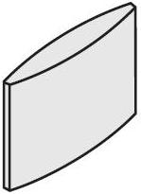 | Concave Lens: | 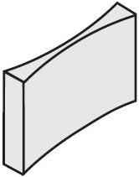

- Select the 5-rays and shine them on a piece of paper. Take the convex lens and focus the rays, so that the focal point is on your page. Sketch the five rays and the exterior shape and position of the lens. Label the focal point. Measure the focal length of the lens, which is the distance between the centre of the lens and the focal point for initially parallel rays.

- Select the 5-rays and shine them on a piece of paper. Take the concave lens and de-focus the rays. Leave enough room on the page so that you will be able to sketch the rays backwards to the virtual focal point from which they appear to be emerging. Sketch the five rays and the exterior shape and position of the lens. Remove the lens and use a ruler to trace the rays backward to the spot from where they all seem to be emerging. Label the virtual focal point. Measure the focal length of the lens, which is related to the distance between the centre of the lens and the virtual focal point for initially parallel rays. Is the focal length for this lens negative or positive?

- Switch the wheel to the red, green and blue thick beams. Using the lenses and these coloured beams, can you create white light?

[INSTRUCTOR HINTS for Activity 5 – note these are not meant for the student guide]
- The image distance is the same as the focal length when the initial rays are parallel. The focal point will not be a perfect point but a region in which all the rays are pretty close.
- This takes some practice to make sure there is enough room on the page to retrace the diverging rays back to a common focal point. Since the image is on the same side of the lens as the light source, it is negative. For initially parallel rays, the image distance is the same as the focal length. Again, the focal point will not be a perfect point but a region in which all the virtual rays are pretty close.
- Students may discover that if the red, green and blue parallel coloured beams are focused with the convex lens, at the focal point the light appears white.

For electronic versions of this handout, the powerpoint slides, and links to many other similar online manuals, please feel free to contact me:
jharlow@physics.utoronto.ca
416-946-4071
Physics Department, University of Toronto
60 St. George St. Toronto ON M5S1A7

